**What will you learn from this module:**

**EXPERIMENT – 2.2**

**BLINK AN EXTERNAL LED USING BUTTON ON DEV BOARD/NODE**

Blink an external LED using button on Development Board/Node.

**Requirements:**

* nRF connect desktop software.
* nRF Command line tools.
* Visual studio code.
* USB cable.
* nRF52832 Development Board/Node.
* LED’s.

**Prerequisites:**

* Basic knowledge of C/C++
* Basic knowledge of communication protocol.
* Basic project setup.

**Setup and Configuration**:

* Open VS Code and go to **Browse samples [1]** and search **Button [2]**.

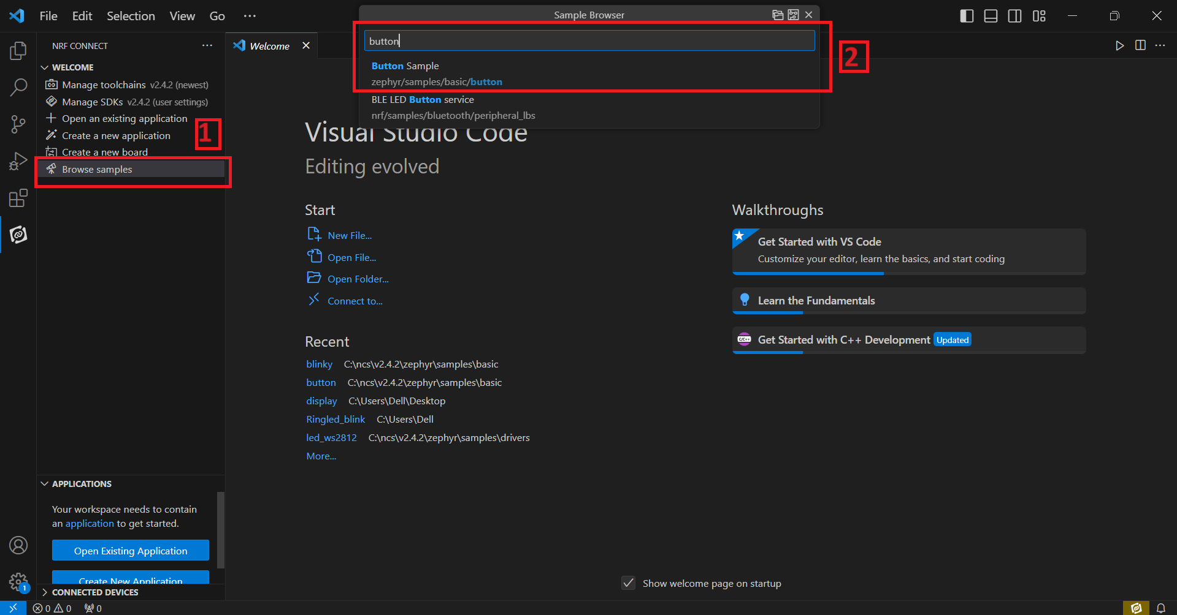

* Click on **Create new build configuration [1]**. Here you can change the board version, if you are using nRF52832, then select **nrf52dk_nrf52832 [2]** or you can change from dropdown menu for another version like nRF52833 etc.
* Click on the Configuration and select **prj.config [3]** from dropdown menu and then **click on the Build Configuration [4]**.

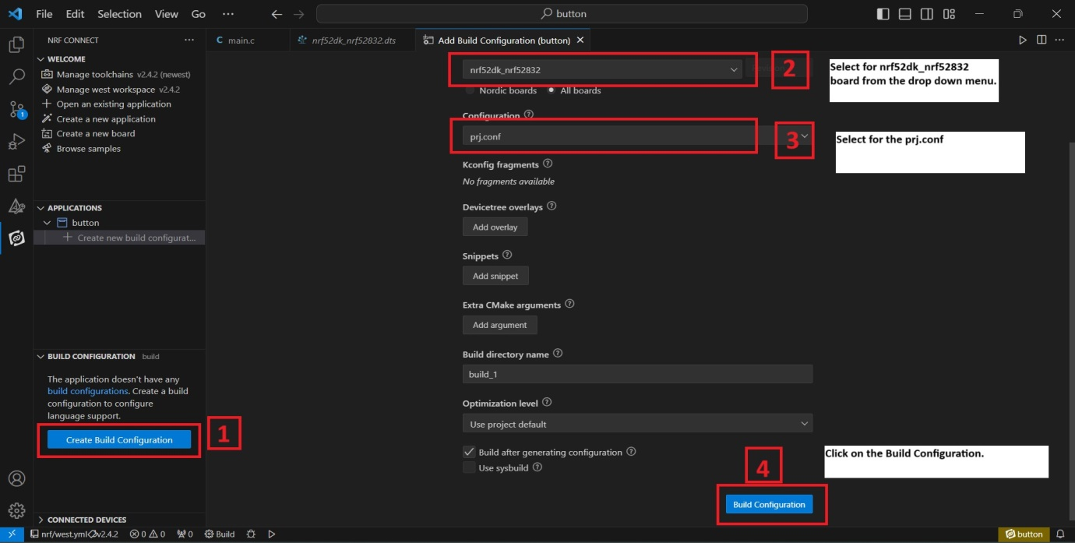

* Go to **source file [2]**,click **source file** > click on **Application** > click on **src [3]** > click on **main.c [4]** .
* By clicking on **main.c** file and you will see the code on your screen.

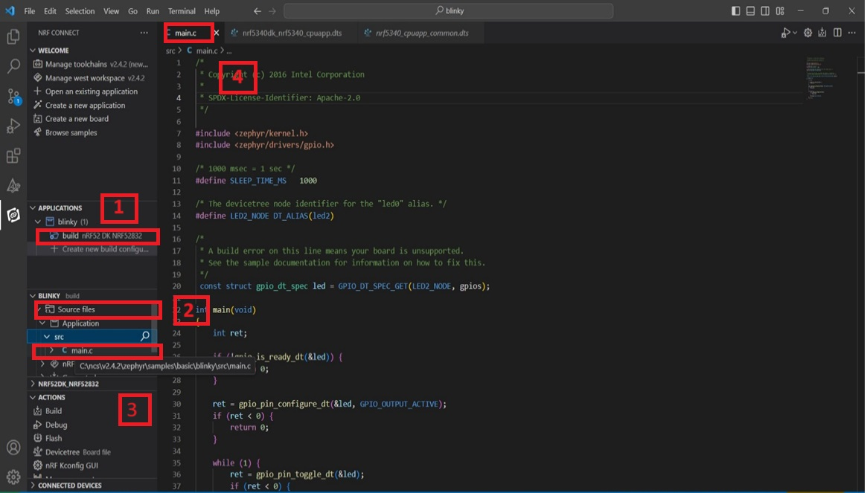

* Click on the **Config files [1]** > **Devicetree** > **.dts file [2]**.
* **Change the gpio pin no. [3]** with the pin that is used by the external led on the nRF board. (for example, if led’s +ve terminal is connected to P0.25 on the development board & -ve terminal to GND, then change the gpio pin no. to 25 in the dts as shown in the figure.

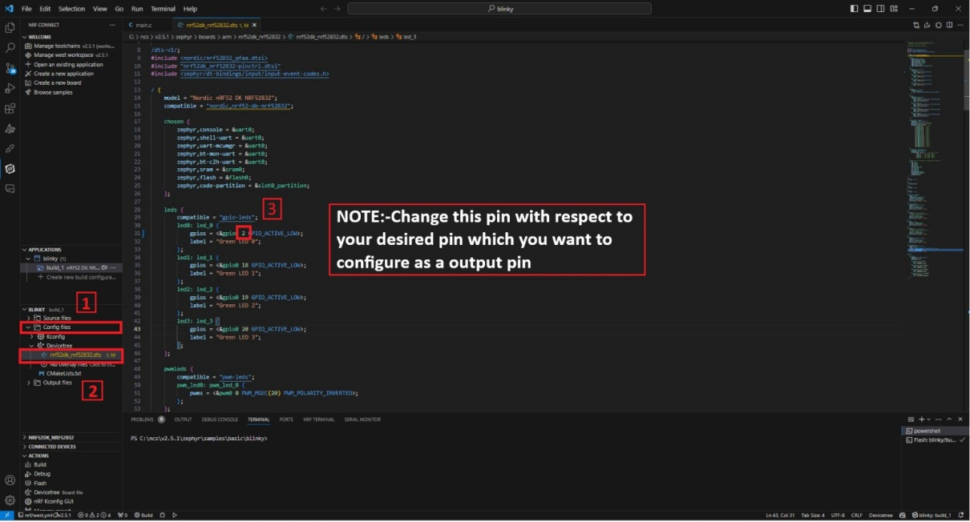

* Run the build configuration again.
* Then flash the code in nRF dev kit.
* Click on **Build [1]** configuration again and check the **CONNECTED DEVICES [2].**
* If device id is visible, then **Flash** the code in Development Kit.
* If **flashed successfully** message is displayed on serial terminal, then flash process is complete.

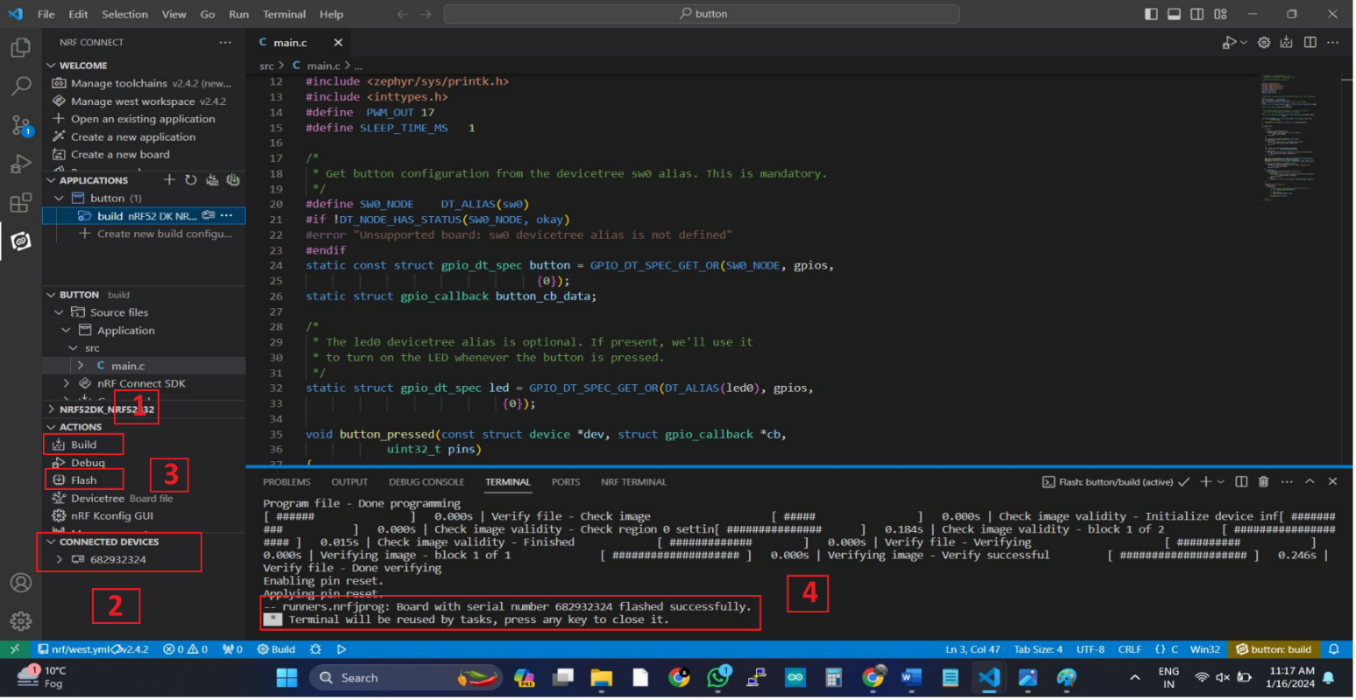

* **PIN CONFIGURATION**

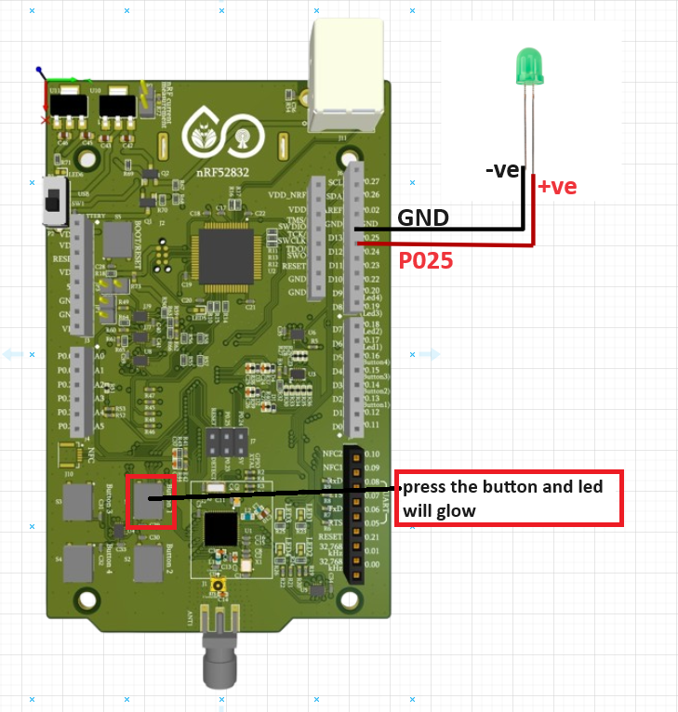

**Board Pins -> LED Pins**

**P0.25V -> +ve terminal**

**GND -> -ve terminal**

* **OUTPUT**

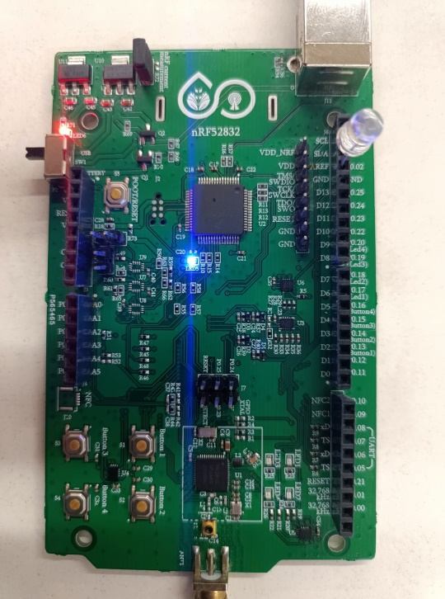

* nRF52832 board after press the button.
* nRF52832 board before press the button.

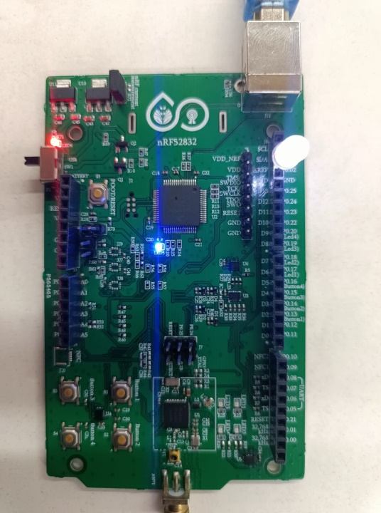

**Press the button and LED will glow**

* **WITH THE HELP OF NODE**

* For Node programing remove the jumper **J2** from the development board.
* Now flash the code with the help of nRF52832 development board as shown below in the figure.

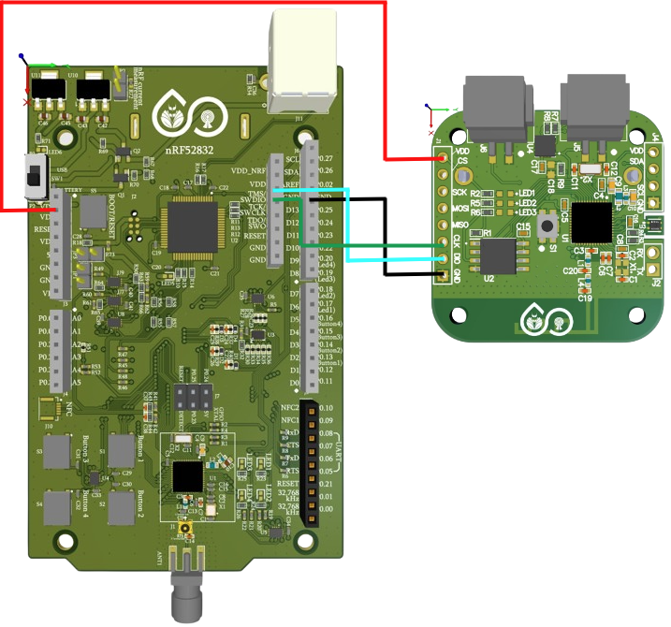

**Board Pins -> NODE Pins**

**VDD(3.3V) -> VDD**

**GND -> GND**

**CLK -> CLK**

**DIO -> DIO**

**Remove the jumper J2 from here.**

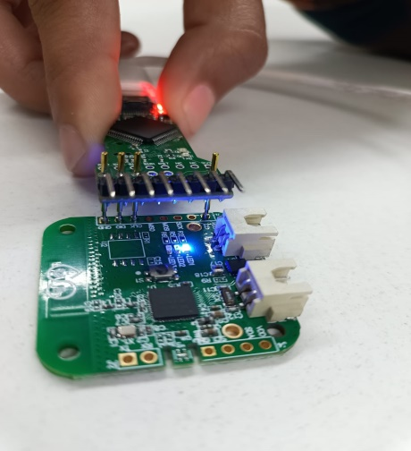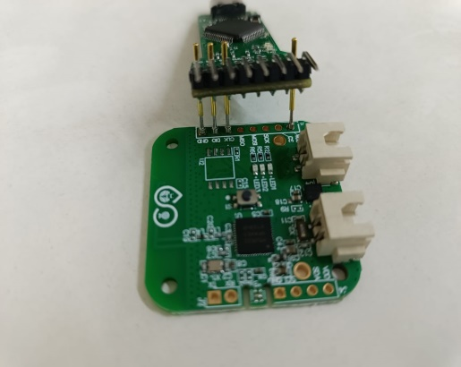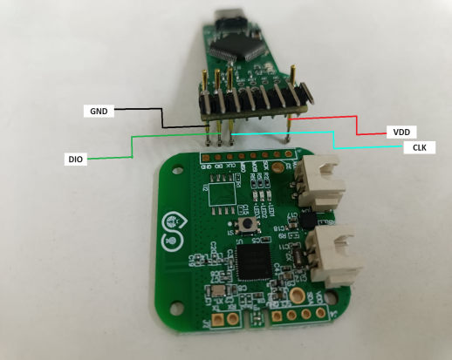

* There is another way of flashing the code with the help of Node Programmer as shown in the picture below.
* NODE after program.
* NODE with connection.
* NODE without connection.
* **PIN CONFIGURATION**

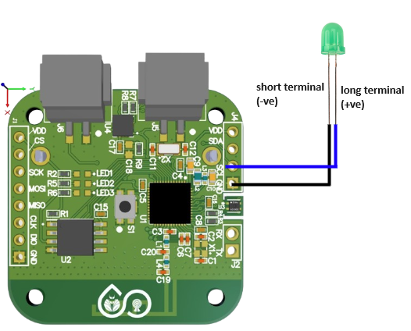

**LED Pins -> NODE Pins**

**+ve -> SCL**

**-ve -> GND**

* **OUTPUT**

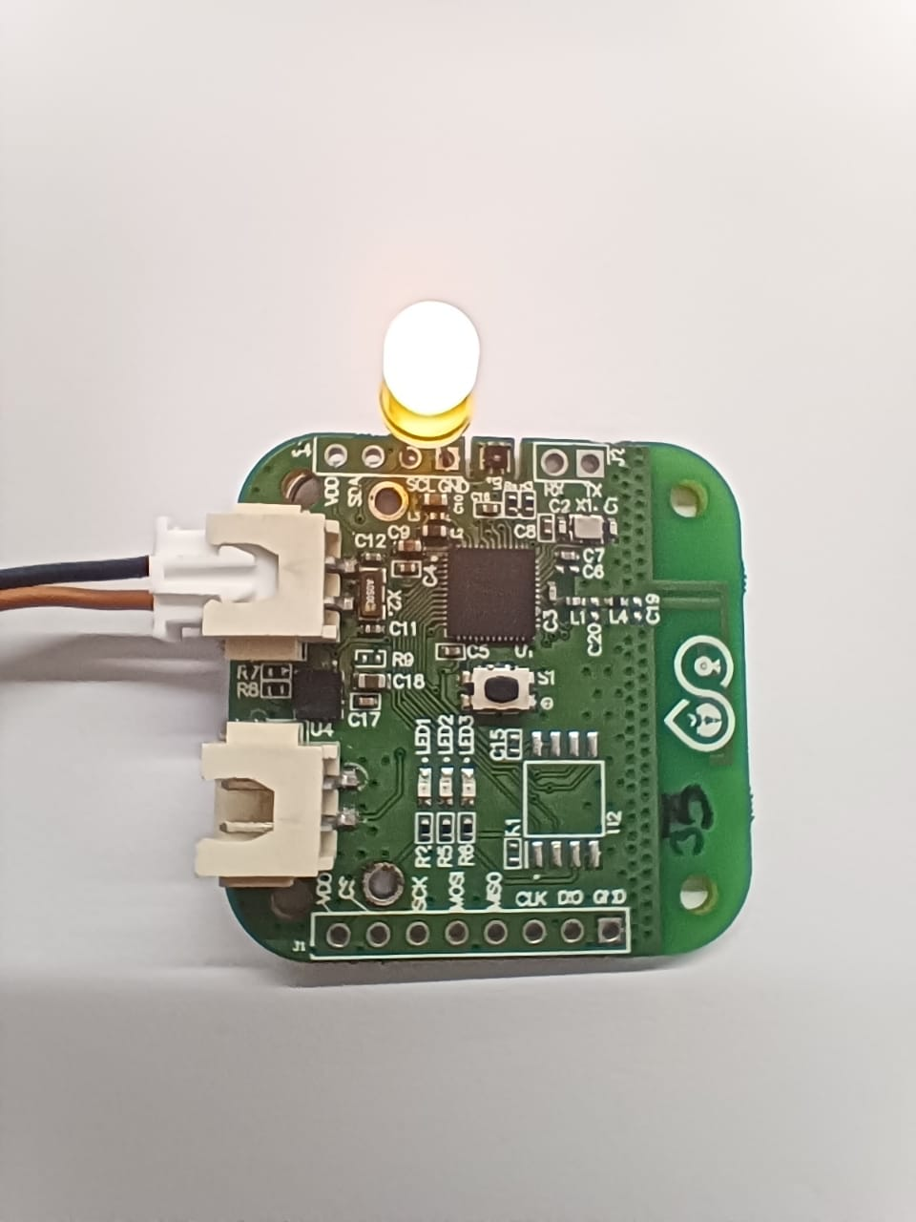

* NODE after flash the code.
* NODE before flash the code.

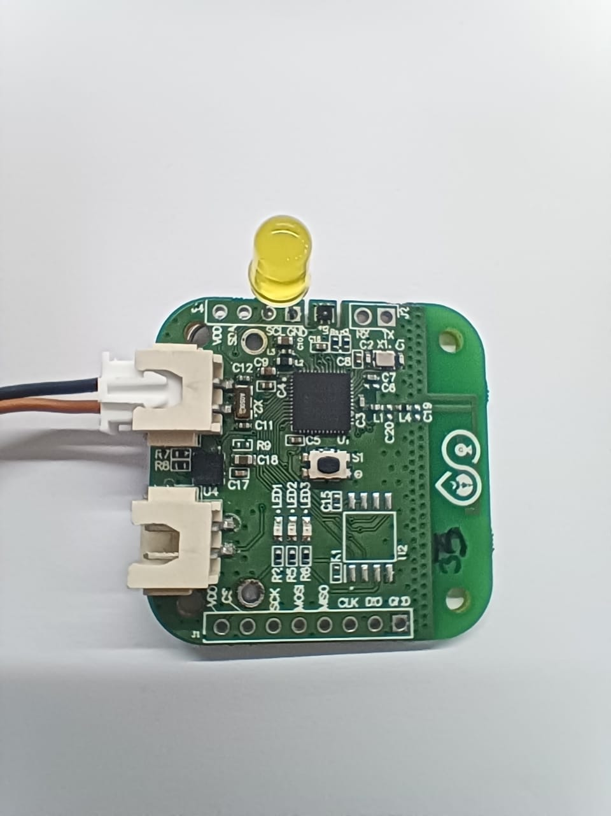

**Press the button and LED will glow**